Week 5 GOALs

Task 1: Create a Stock table which links the product table with the warehouse table and contains the attributes given in the table below. You are expected to give each attribute a relevant name and data type, and to correctly define the primary key and foreign keys:

I used CREATE TABLE Stock, to create a new table named Stock.

Screenshot:

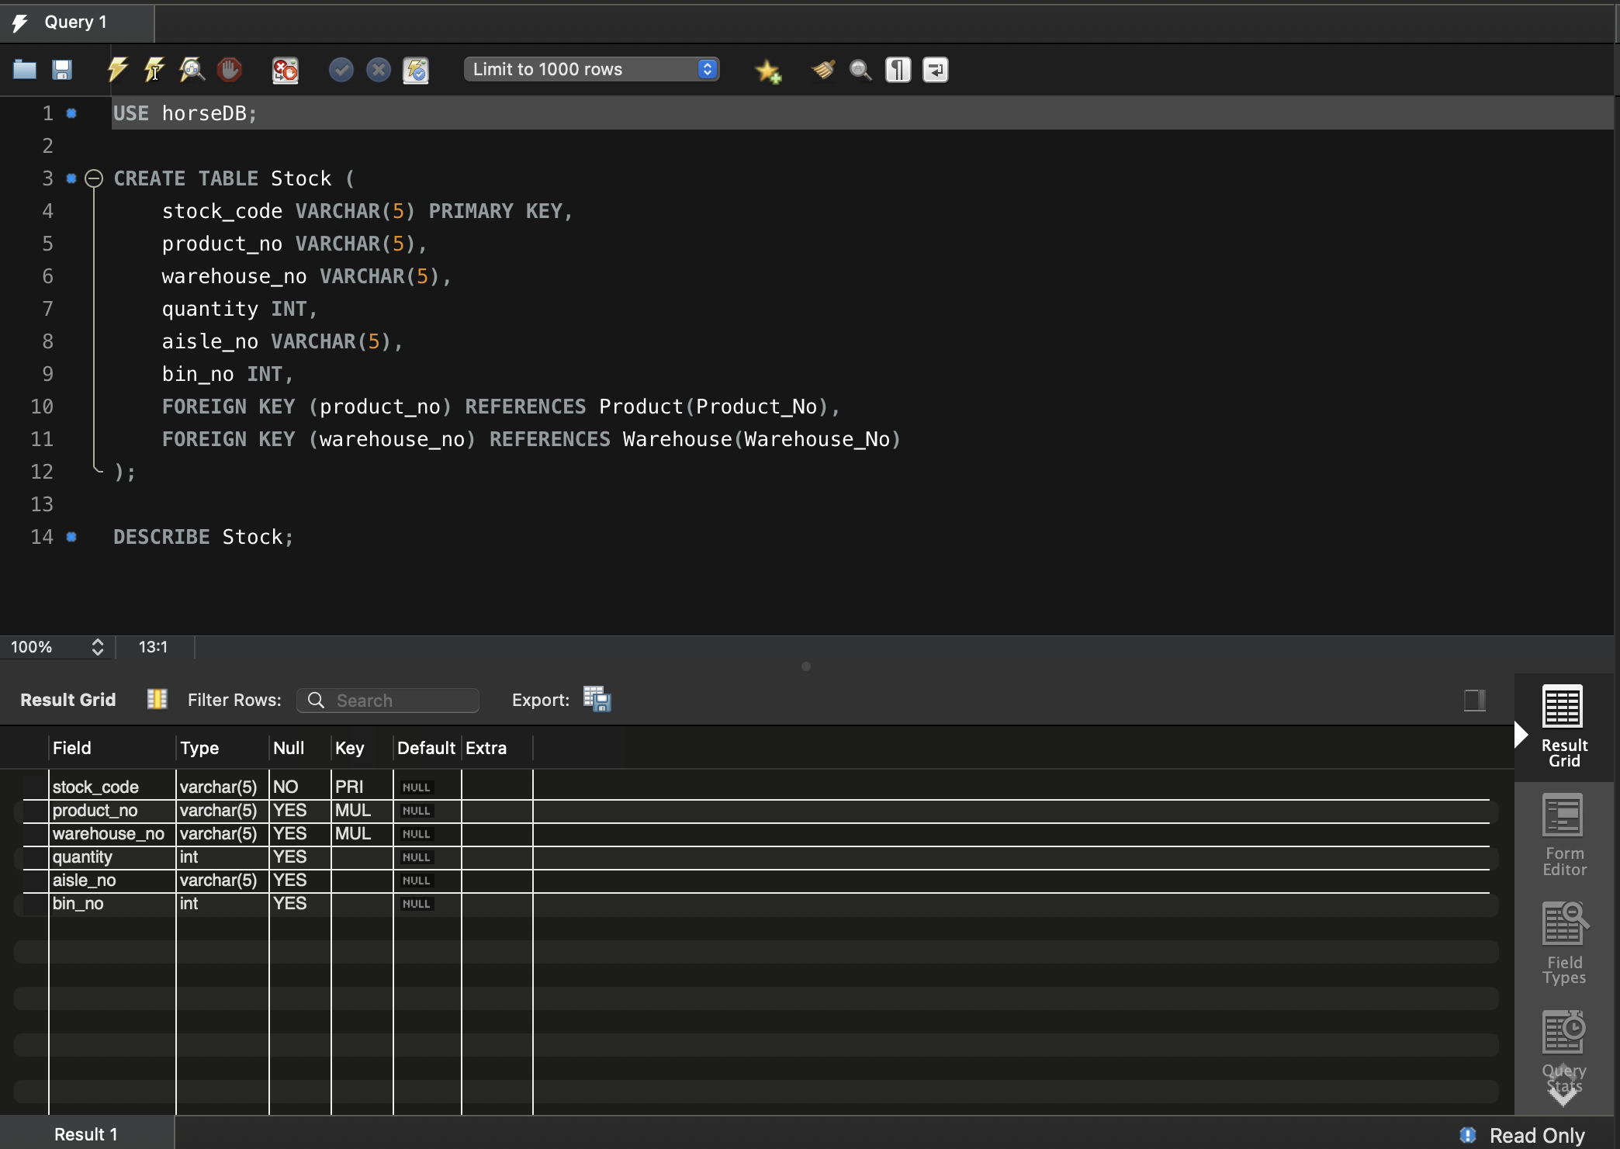

Task 2: Populate the table with at least 5 rows of data. Make sure the data is realistic and the Entity and Referential Integrity Constraint are not violated:

I used INSERT INTO Stock to insert data into the table inserting new rows into the table.

Screenshot:
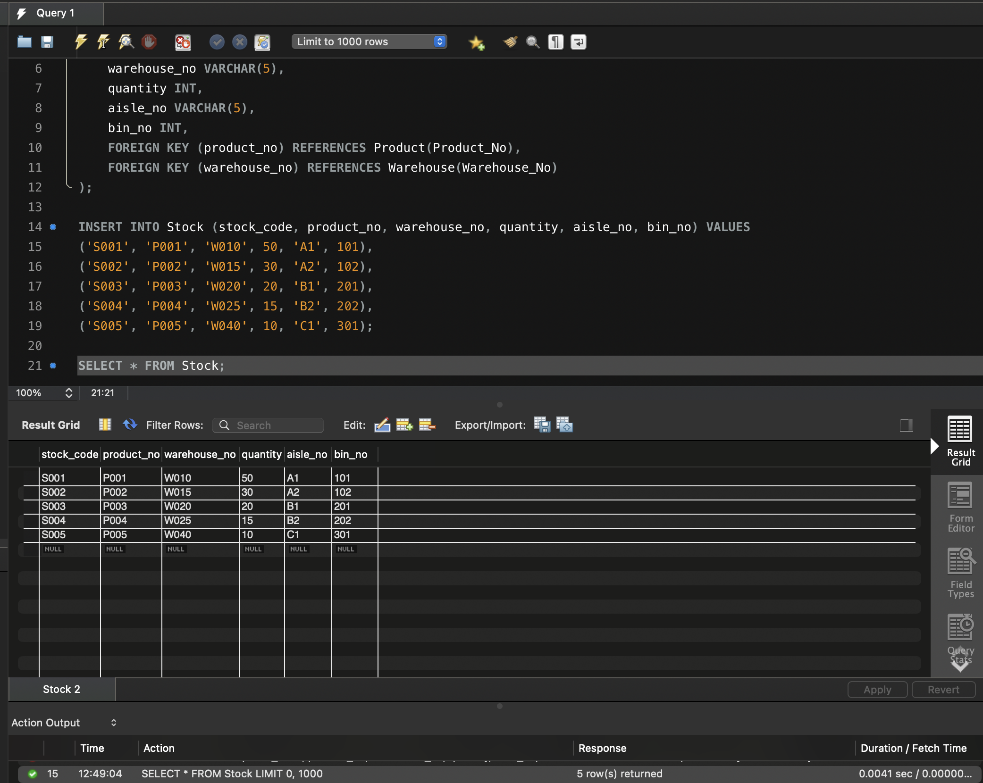

I5.1. The correct use of the CREATE TABLE statement:

I used The CREATE TABLE statement correctly as shown in the image below

Screenshot:

I5.2. Relevant attribute names:
I Ensured that the attribute (column) names in the Stock table are:
  - Descriptive and clearly indicate the data they store.
  - Consistent with the naming conventions used in the HorseDB database.
  - Meaningful and easy to understand.

I5.3 Relevant domain types:

I Ensured that the data types used for each attribute in the Stock table are:
- Appropriate for the type of data they store.
- Consistent with the data types used in the related Product and Warehouse tables.
- Efficient in terms of storage and performance.

I5.4. Correctly defined Primary Key:

I Ensure that the Stock table has a Primary Key that:
- Uniquely identifies each row in the table.
- Is not null and unique for every entry.
- Maintains entity integrity by preventing duplicate or null values.

I5.5 Correctly define the Foreign Keys:

In my CREATE TABLE statement, I defined:
FOREIGN KEY (product_no) REFERENCES Product(Product_No),
FOREIGN KEY (warehouse_no) REFERENCES Warehouse(Warehouse_No)
I also used the lines:
  - Link product_no to the Product_No column in the Product table.
  - Link warehouse_no to the Warehouse_No column in the Warehouse table.
This ensures that:
  - Only valid product_no values from the Product table can be used.
  - Only valid warehouse_no values from the Warehouse table can be used.

I5.6. The correct use of the INSERT INTO statement:

I used the INSERT INTO statement correctly to add new rows of data into the Stock table.

I Ensured that:
- The statement specifies the column names and the corresponding values.
- The data is inserted in the correct order matching the column list.
- Multiple rows are inserted in one go for efficiency.
Screenshot:

I5.7. The correct use of the VALUES statement:

I correctly used the VALUES statement in my INSERT INTO command and ensured:
- Providing values for each column listed.
- Maintaining the correct order corresponding to the column list.
- Using appropriate data types for each value.
- Inserting multiple rows efficiently in one statement.

I5.8. Relevant data inserted into table:

I Ensured that the data inserted into the Stock table is:
- Realistic and meaningful, reflecting actual stock scenarios.
- Consistent with the existing data in the Product and Warehouse tables.
- Accurate in terms of quantities, locations, and product-warehouse relationships.
- Relevant to the context of a company selling horse accessories.

Screenshot:
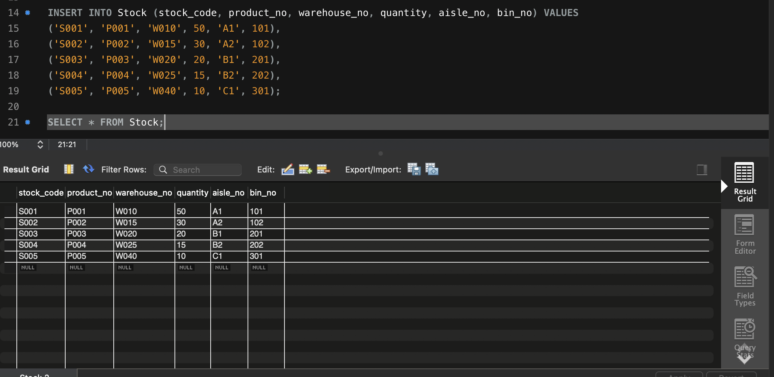

I5.9. Demonstrate that the Entity Integrity constraint is not violated:

- I correctly demonstrated entity integrity in my stock table, as I defined Stock_code as the Primary Key:

This ensures that:
- Each row is uniquely identified by stock_code.
- No two rows can have the same stock_code.
- stock_code cannot be null or empty for any row.

I5.10. Demonstrate that the Referential Integrity constraint is not violated:

I defined the Foreign Keys as:
FOREIGN KEY (product_no) REFERENCES Product(Product_No),
FOREIGN KEY (warehouse_no) REFERENCES Warehouse(Warehouse_No)

The Foreign keys make sure that:
product_no references Product_No in the Product table. And warehouse_no references Warehouse_No in the Warehouse table. So only existing products can be referenced in Stock and Only existing warehouses can be referenced in Stock.

I maintained Referential Integrity as, all product_no values (P001 to P005) exist in the Product table, All warehouse_no values (W010 to W040) exist in the Warehouse table. And You cannot insert or update a product_no or warehouse_no in Stock that doesn't exist in the referenced table. You also can’t delete a referenced Product_No or Warehouse_No from product or Warehouse tables without first removing the related rows from Stock.

Referential Integrity screenshots:
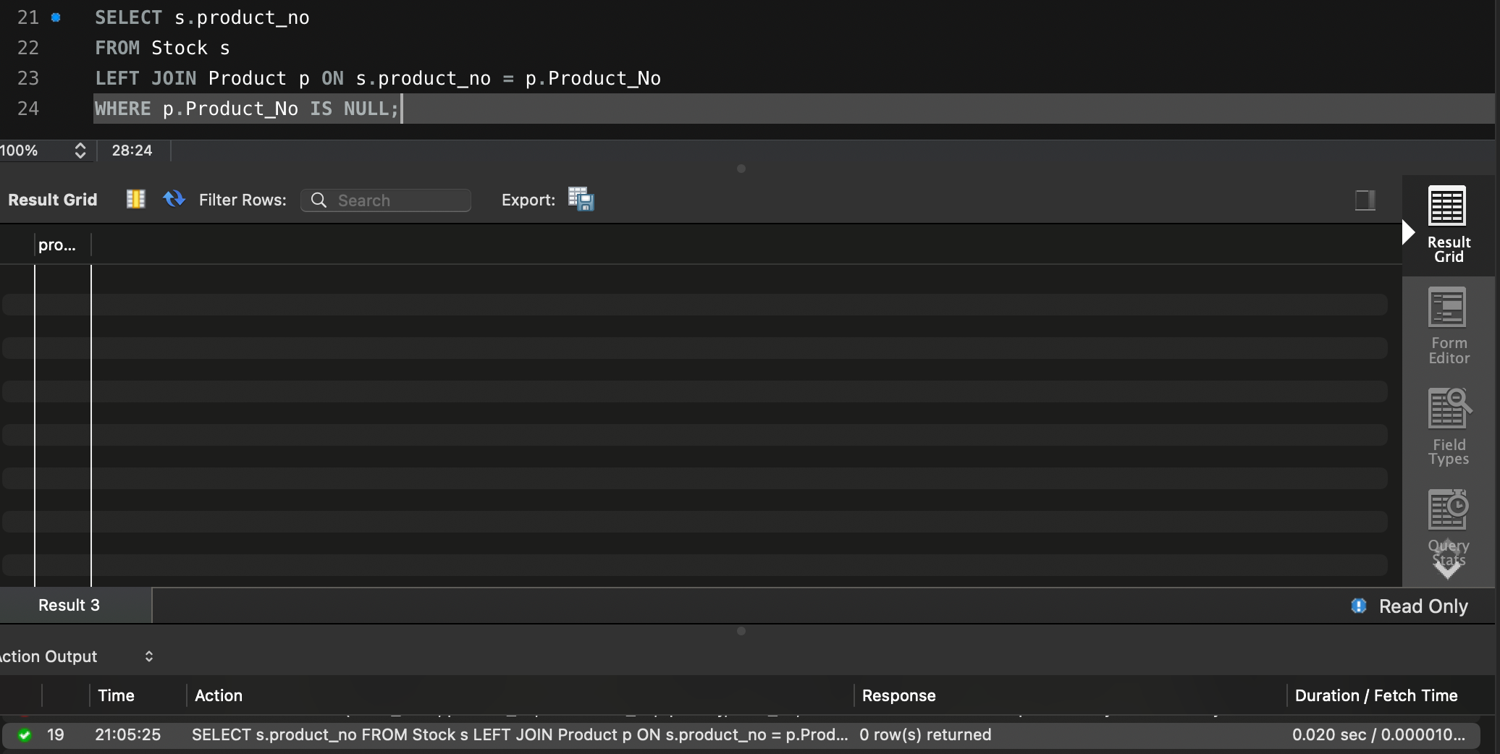

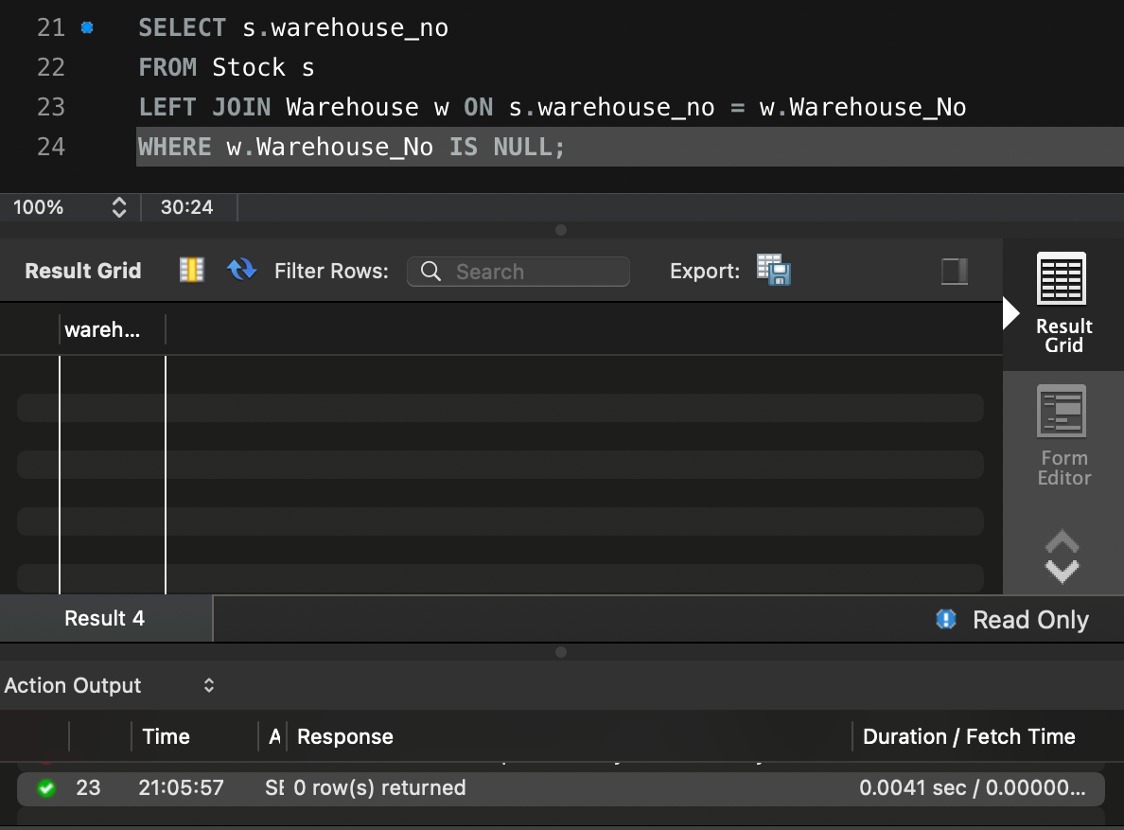

Results we can see from screenshots:
- No rows are returned for both queries.
- This confirms:
  - No orphaned product_no values.
  - No orphaned warehouse_no values.

